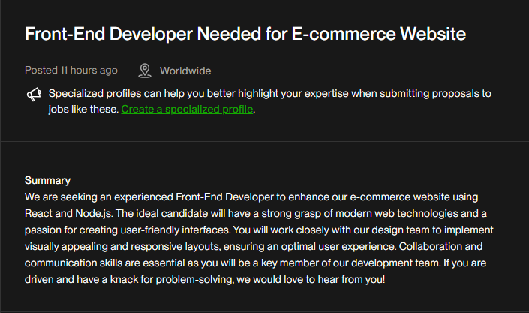

Financial Proposal

**Submitted by:** Abdelrahman Elmoursi  
**Project Title:** Front-End Enhancement for E-Commerce Website  
**Date:** July 30, 2025

**Project Overview**

This proposal outlines the financial and technical details for enhancing an existing e-commerce platform. The work will be focused on the front-end development using **React** in coordination with the backend powered by **Node.js**.

**Scope of Work:**

* Collaborate with the design team to implement high-fidelity and responsive layouts.
* Develop and refine reusable React components.
* Integrate front-end interfaces with Node.js APIs.
* Ensure cross-browser compatibility and accessibility standards.
* Optimize website performance and responsiveness.
* Conduct thorough testing and fix reported issues.

**Estimated Cost Breakdown**

| **Task Description** | **Estimated Hours** | **Rate (USD/hour)** | **Subtotal (USD)** |
| --- | --- | --- | --- |
| Project Planning & Communication | 5 hrs | $20 | $100 |
| UI Integration with React | 30 hrs | $25 | $750 |
| Responsive Design Implementation | 10 hrs | $25 | $250 |
| Backend API Integration (Node.js) | 15 hrs | $25 | $375 |
| Testing & Debugging | 10 hrs | $20 | $200 |
| Performance Optimization | 8 hrs | $25 | $200 |
| Final Review & Delivery | 2 hrs | $20 | $40 |
| **Total Estimated Cost** | — | — | **$1,915** |

### ****Project Timeline****

Estimated duration: **3 to 4 weeks**

### ****Payment Terms****

* **30% upfront** upon approval: **$575**
* **40% upon mid-project delivery:** **$766**
* **30% upon final delivery:** **$574**

### ****Additional Notes****

* This proposal does not include costs related to hosting, domain registration, or third-party services unless explicitly stated.
* Additional revisions or tasks outside the defined scope will be billed at **$25/hour**.
* This offer is valid for **15 days** from the date of submission.

Technical Proposal

**Submitted by:** Abdelrahman Elmoursi  
**Project Title:** Front-End Enhancement for E-Commerce Website  
**Date:** July 30, 2025  
**Proposal Validity:** 15 Days

### ****1. Introduction****

This technical proposal outlines my approach and methodology to enhance your e-commerce platform using modern front-end technologies, mainly **React**, with close integration to a **Node.js** backend. My goal is to improve user experience, performance, and responsiveness while maintaining clean, scalable code.

### ****2. Objectives****

* Improve UI/UX by translating high-fidelity designs into responsive React components.
* Optimize website performance (loading speed, responsiveness, and smooth interactions).
* Ensure accessibility and cross-browser compatibility.
* Seamless integration with the backend APIs (Node.js).
* Write reusable, maintainable, and scalable code using best practices.

### ****3. Technologies to Be Used****

| **Layer** | **Technology** |
| --- | --- |
| Front-End | React.js (with Hooks + JSX) |
| Styling | CSS Modules / Tailwind CSS / Styled Components (as preferred) |
| State Mgmt | Redux / Context API (as needed) |
| Backend APIs | Node.js (already provided) |
| Version Ctrl | Git & GitHub |
| Tools | ESLint, Prettier, Webpack/Vite, Postman |
| Testing | Jest / React Testing Library |

**4. Project Workflow**

| **Phase** | **Description** |
| --- | --- |
| **1. Requirement Review** | Understand current codebase and gather full feature scope with the team. |
| **2. UI/UX Integration** | Convert Figma or design files into responsive React components. |
| **3. API Integration** | Connect front-end to the Node.js backend via REST APIs or GraphQL if used. |
| **4. Optimization** | Improve loading performance (lazy loading, code splitting). |
| **5. Testing & QA** | Test across multiple browsers and devices. Fix bugs and UX issues. |
| **6. Deployment Support** | Assist in deploying updates if required. |

**5. Estimated Timeline**

| **Task Group** | **Duration (approx.)** |
| --- | --- |
| Requirement Analysis | 2-3 days |
| UI Development | 1.5 – 2 weeks |
| API Integration | 4 – 5 days |
| Optimization & Testing | 4 – 5 days |
| Final Review | 1 – 2 days |
| **Total** | **3 – 4 weeks** |

### ****6. Deliverables****

* Clean, documented React codebase integrated with backend
* Fully responsive UI
* Reusable components and structure
* Browser compatibility report
* Deployment-ready build
* Testing coverage (unit or integration as agreed)

### ****7. Why Me****

* Solid experience with React and front-end architecture
* Focused on performance, responsiveness, and user experience
* Efficient communicator and team collaborator
* Committed to writing clean, reusable code
* Ready to start immediately

### Notes

* This proposal assumes that the backend (Node.js) and API specifications are already available.
* If required, I can also assist in backend debugging or minor adjustments.
* Any extra features or redesign outside the discussed scope can be estimated separately